**Update Resumes To Talentio Portal**

To update your resumes into the Talentio Portal,

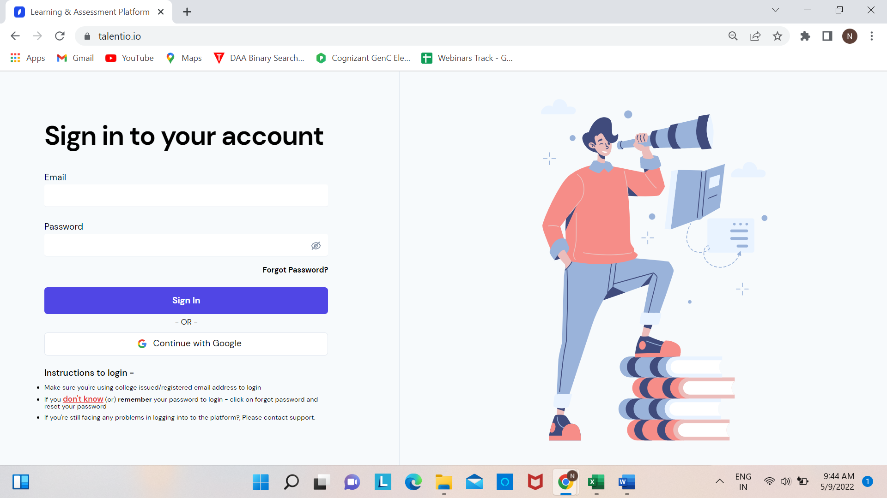

Login to **Talentio.io** portal

Once you login, on the **Dash Board** you will find **Edit Profile**

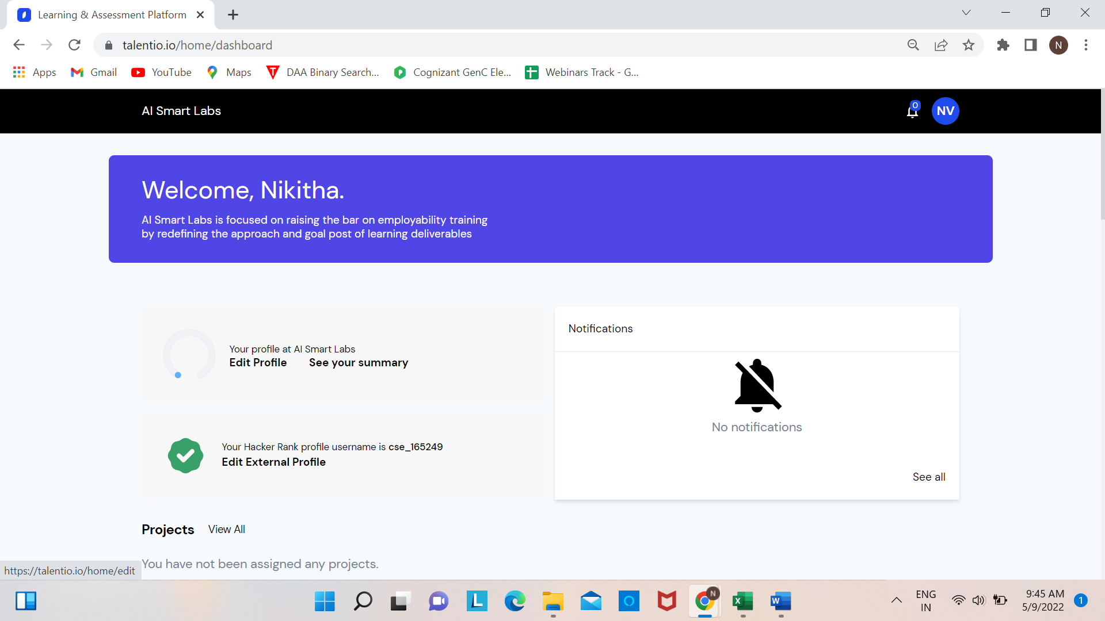

Click on **Edit Profile**

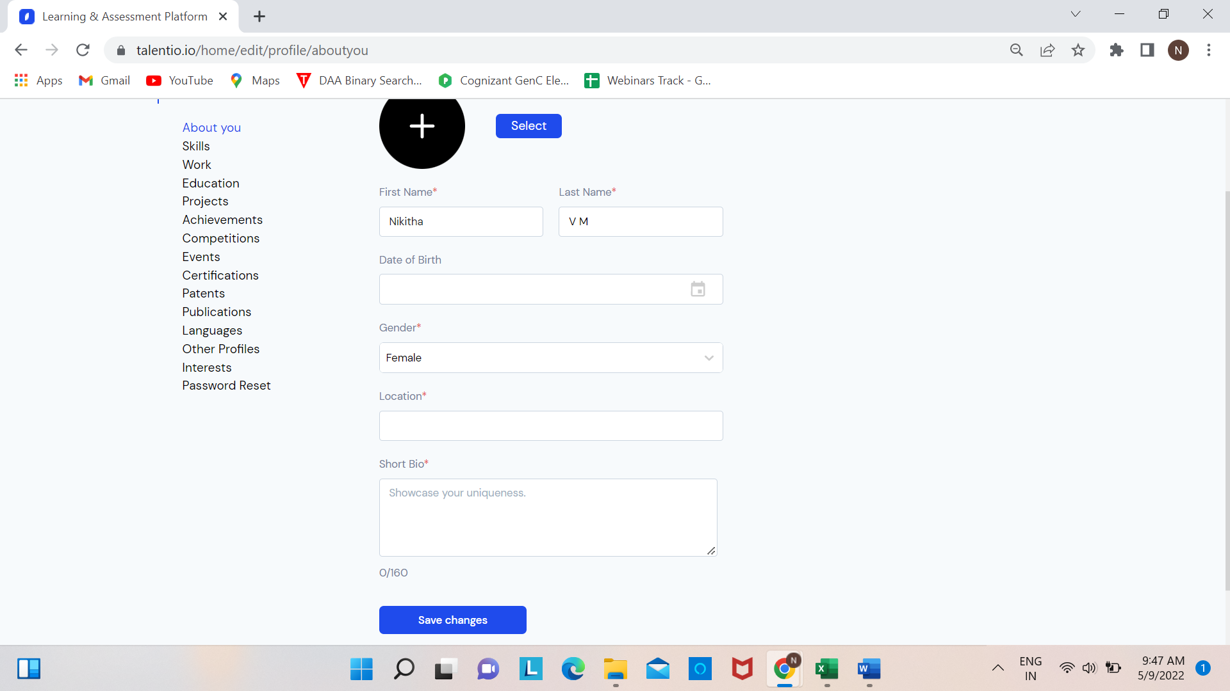

Update your details under **About You,** and **Save Changes**

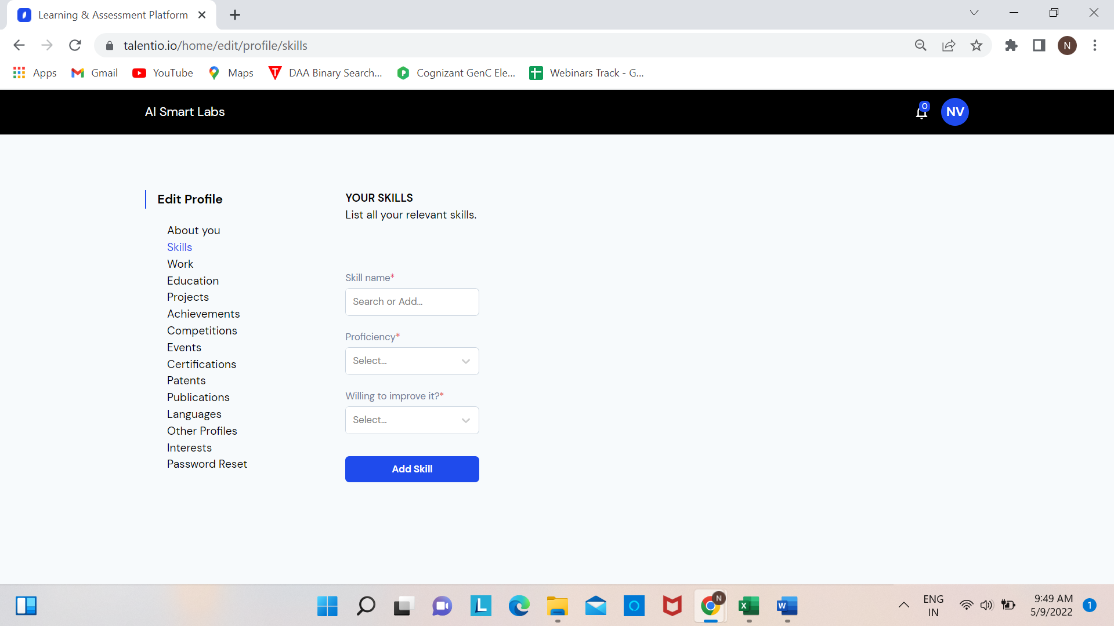

Update **Skills** and Click **Add Skill,** Here you can add Multiple Skills

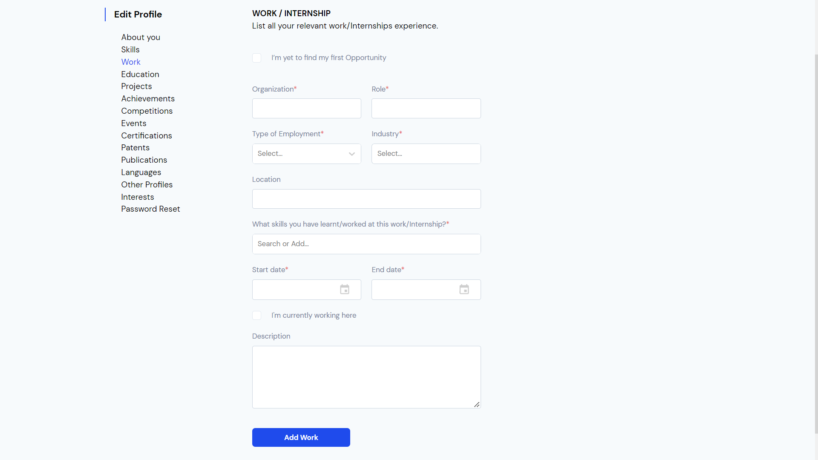

If you have any **Internships or Work Experience** you can update and click **Add Work**

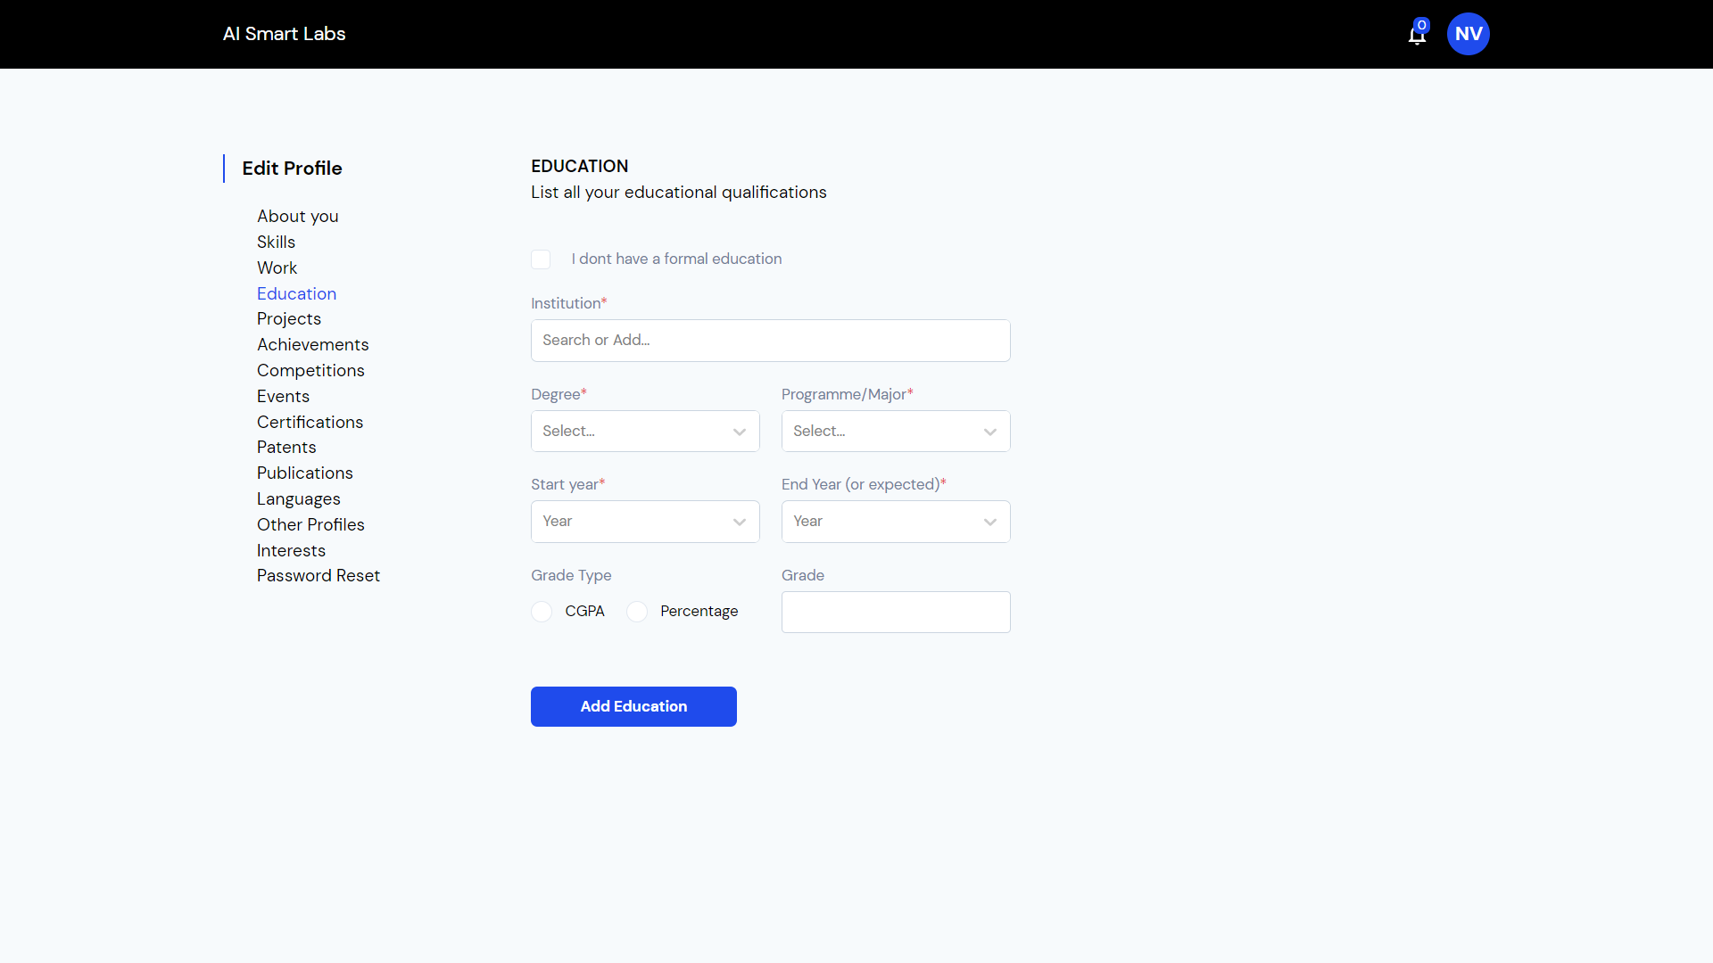

You Can Add all your **Education Background** and click **Add Education**

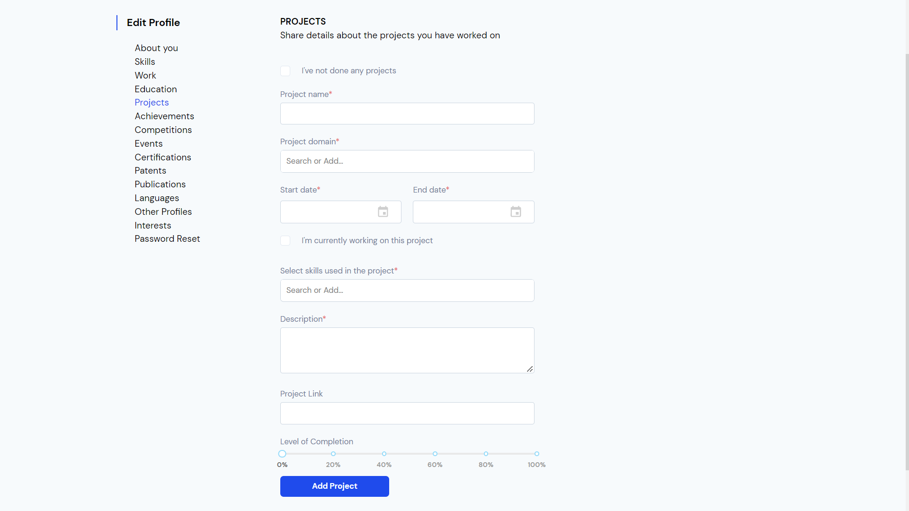

If you have already done any **Projects** you can add the details here, and click **Add Project**

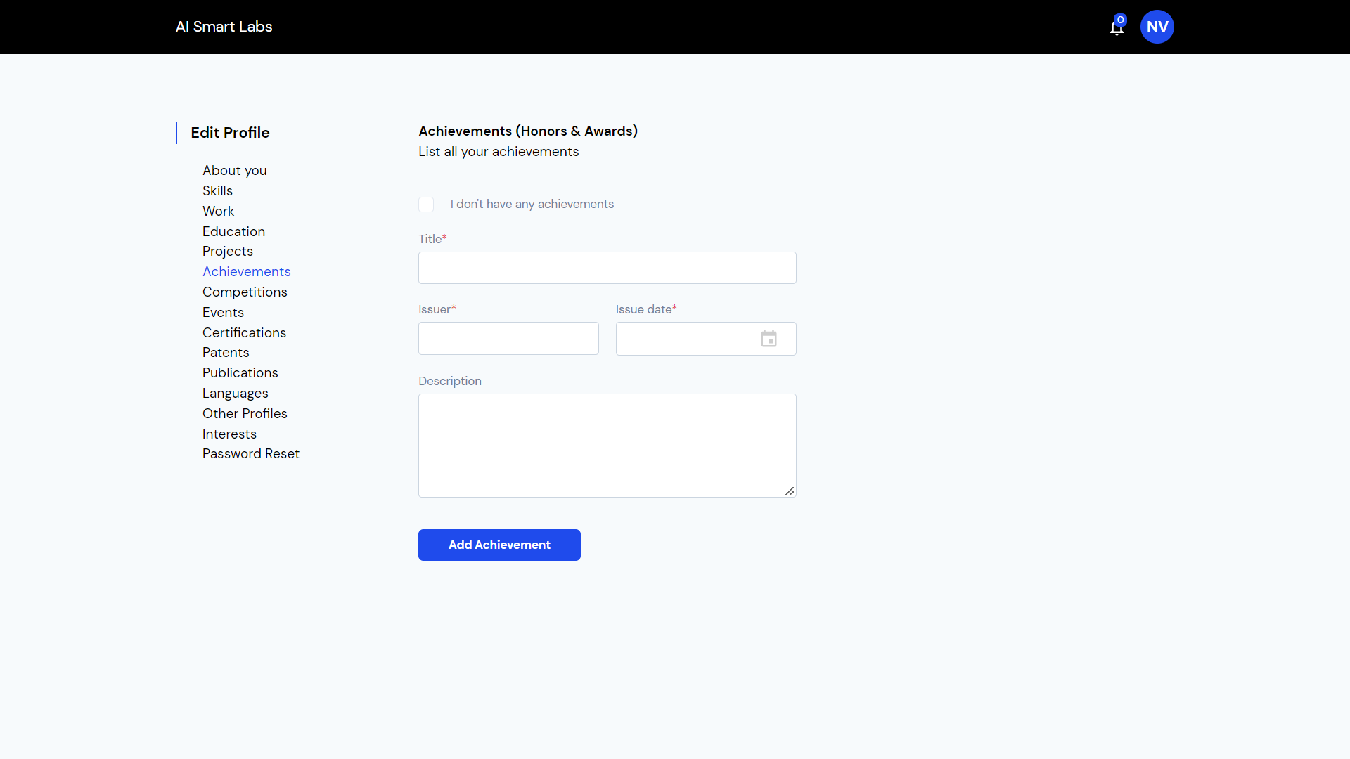

You can update your **Achievements** and click **Add Achievments**

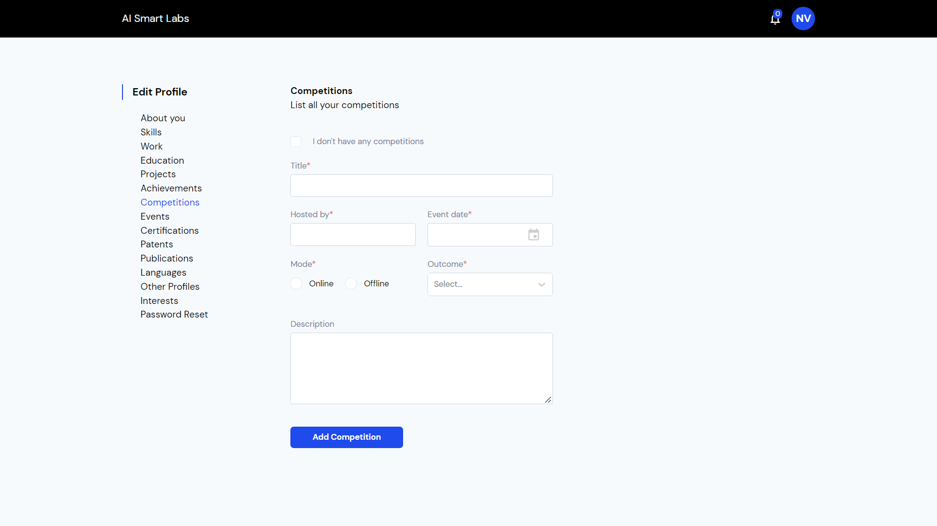

Update the List of **Competitions** that you have take part of and click **Add Competition**

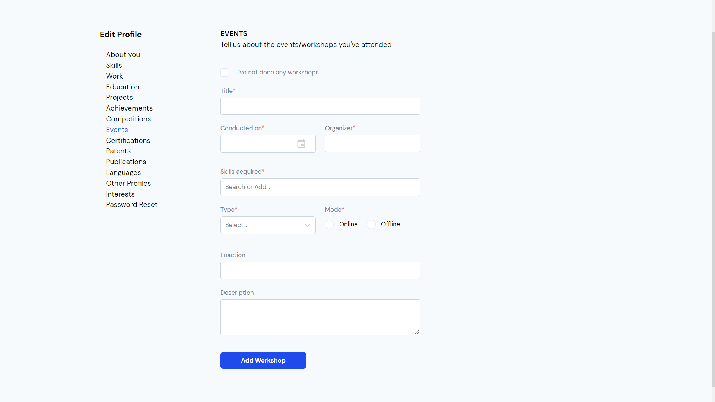

Update the details of **Events and Workshops** attended

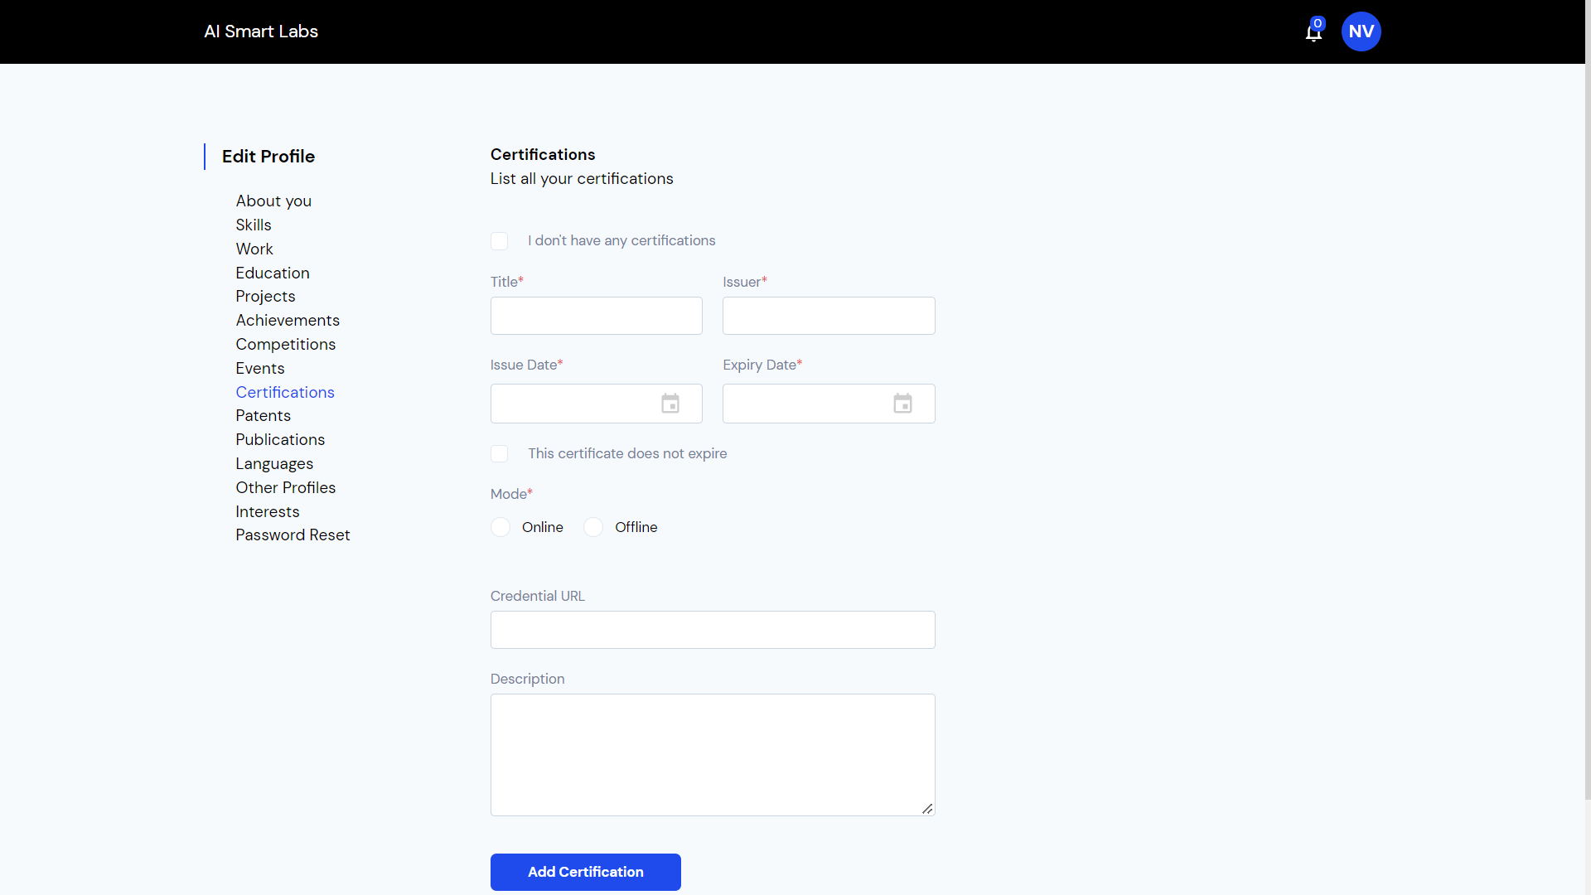

Update all your **Certifications** if any.

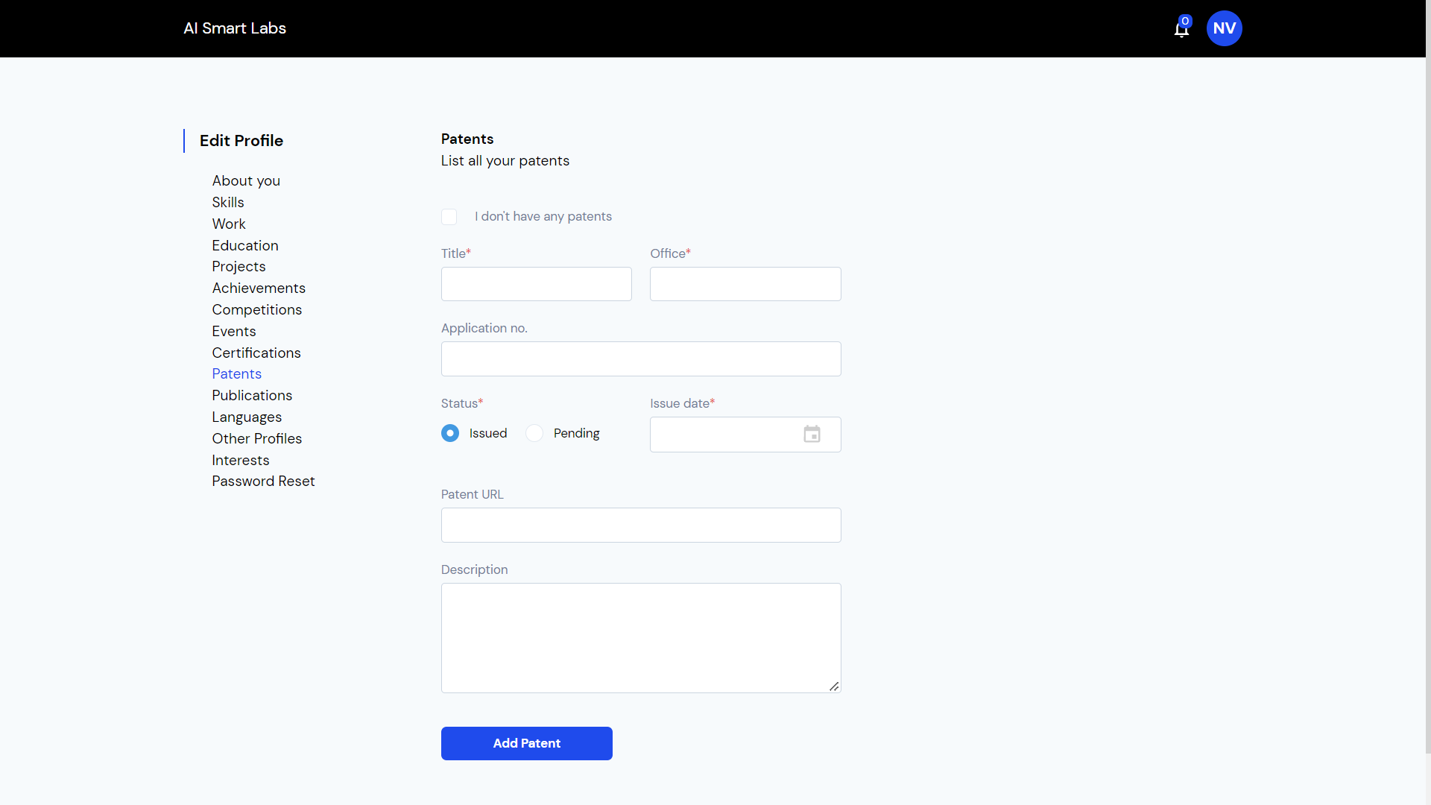

Update all your **Patents** if any.

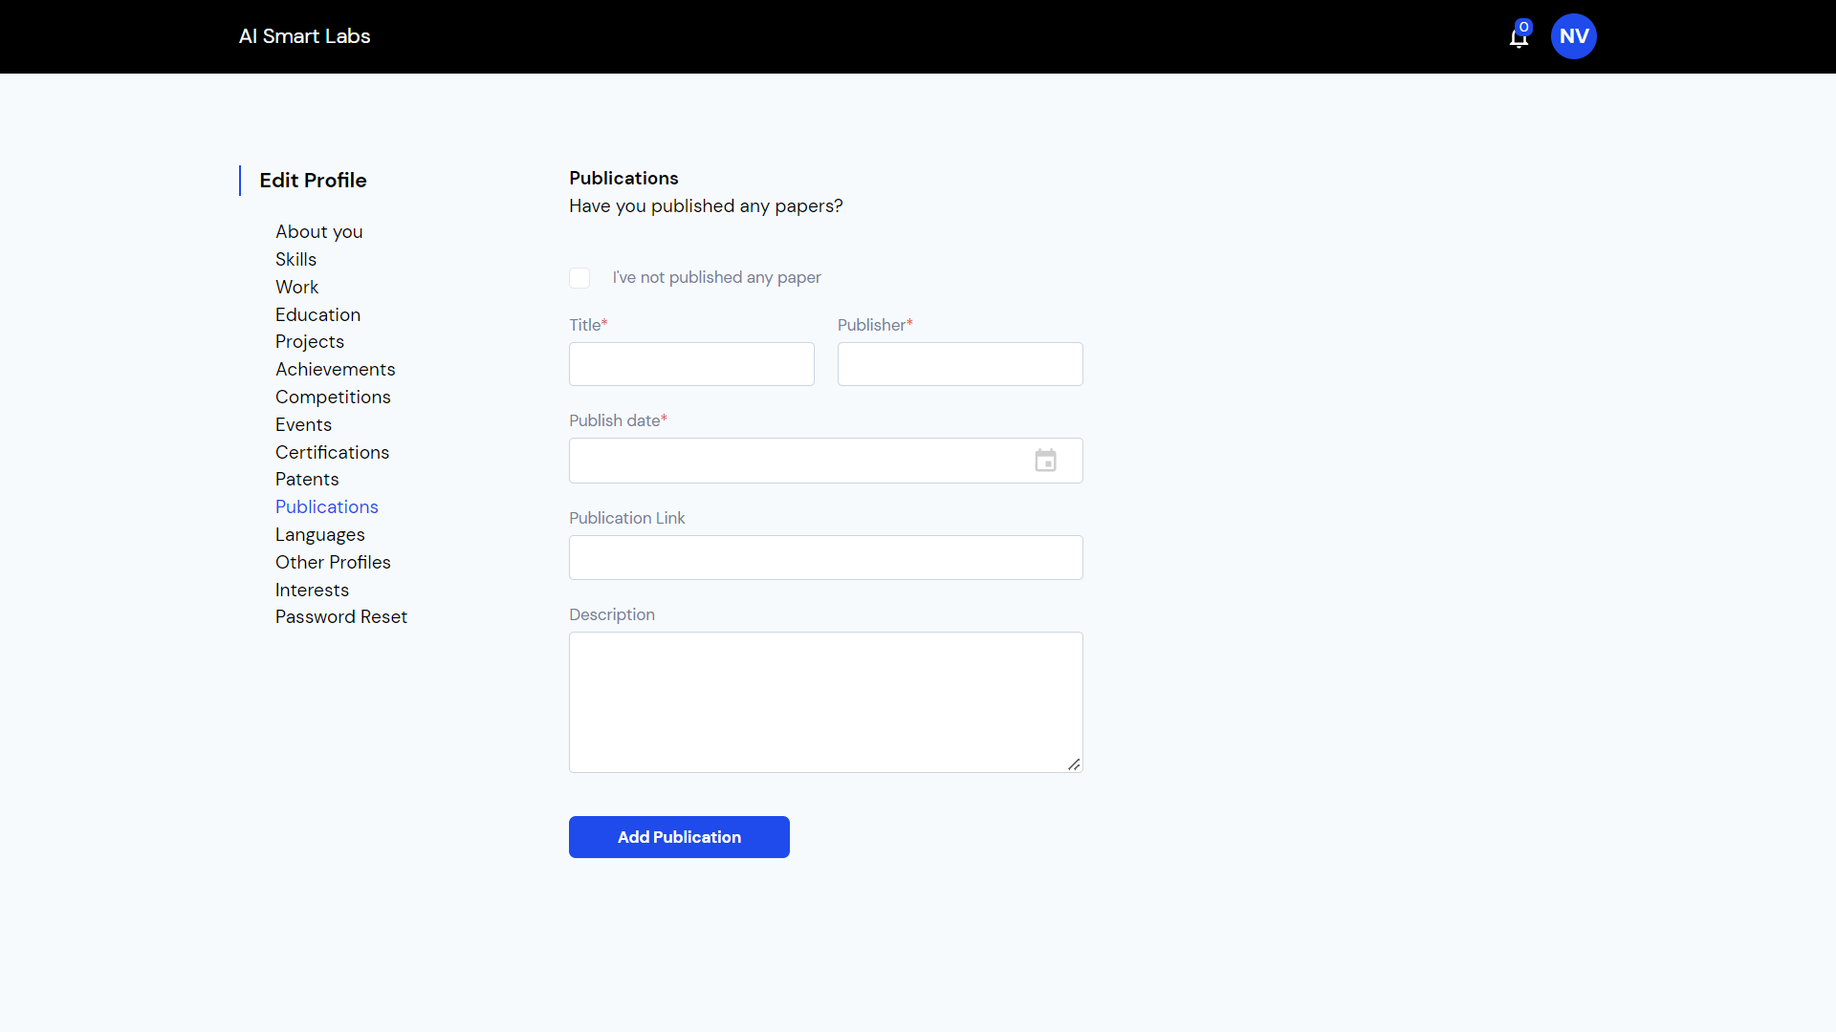

Update all your **Publications** if any.

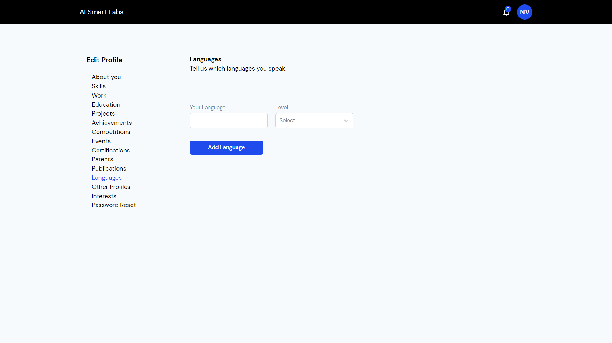

Update the **Languages** you know.

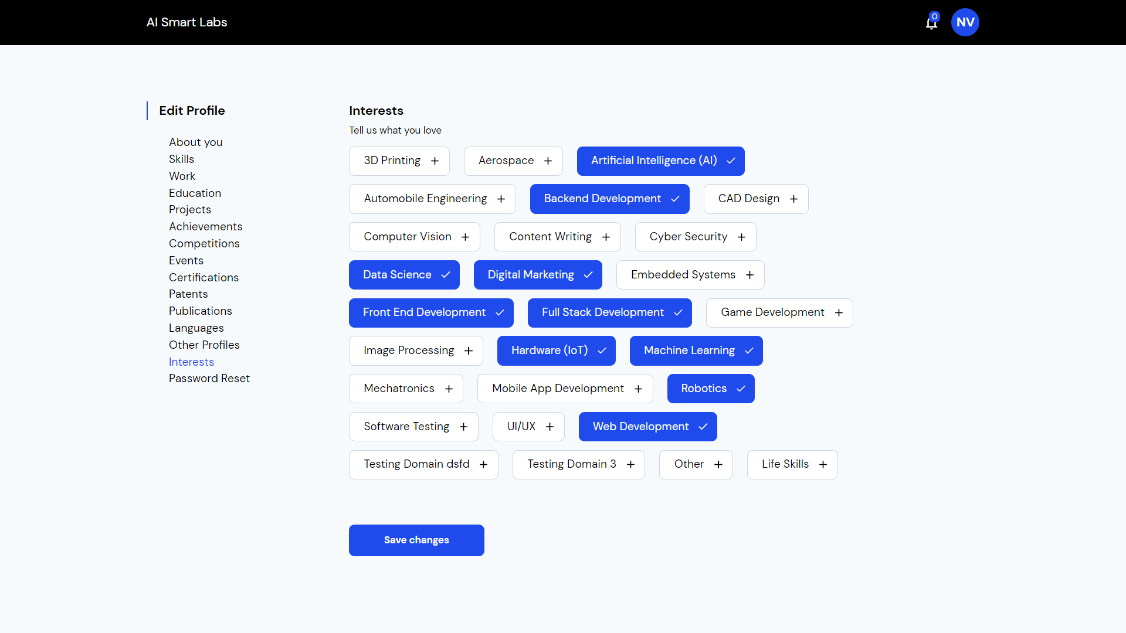

Choose all your **Interests** and **Save Changes**